**Internet of Things**

**Critical Analysis**

bit.ly/3vTYAA2

|  |  |
| --- | --- |
| Name | Martin Strelec |
| Date | 16/4/2024 |
| Student No | S00256070 |
| Student Email | s00256070@atu.ie |
|  |  |

### **Critical Analysis** [**- see slides here**](https://docs.google.com/presentation/d/193MMMz7EaoHWorLezZqeiO9gTh3cI20Jm06GoyJhtnw/edit?usp=sharing)

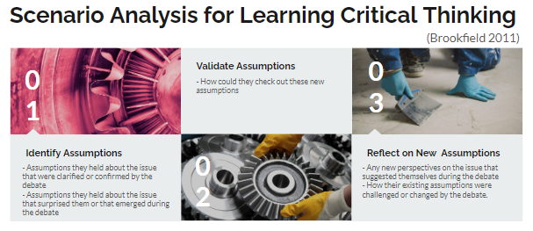



### 

|  |
| --- |
| **Draw the variables in your system in the format of a Bayesian Network**  1. Draw the node you are trying to optimise in your system - e.g. OPTIMISE HYDRATION 2. Draw each node that will influence this dependent variable 3. Draw edges between nodes that influence each other 4. Calculate percentages of probabilities for each node (should add up to 100%)  Individual Diagram Group Diagram **What *effect* does your system have?**  **It has an effect on the living conditions and the health of the user** **On individuals?** **It provides data analysis and control of individuals home and living space** **On society?** **It will set a new standard for living conditions amongst all** |
|  |

### **2. Identify Assumptions**

**What assumptions did you make in designing your system?**

|  |  |
| --- | --- |
| Overall System | AI Elements of the system |
| 1. Person’s health is affected by his living conditions  2. People are lazy or don’t have time  3. People want to live in healthier environment  4. People want a simple and cheap device | 1. Not using AI  2. Not using AI  3. Not using AI  4. Not using AI |

### 

### **3. Validate Assumptions**

**How could you check whether these assumptions are true?**

|  |  |
| --- | --- |
| Overall System | AI Elements of the system |
| 1. Do a research  2. Do a survey  3. Do a research  4. Who wouldn’t want something simple and cheap? | 1. Not using AI  2. Not using AI  3. Not using AI  4. Not using AI |

### 

### **4. Reflect on New Assumptions**

**What new insights have you gained by identifying and validating your assumptions?**

|  |  |
| --- | --- |
| Overall System | AI Elements of the system |
| 1. In most cases the mental health is based on your living conditions  2. People often want to improve their living conditions, but they don’t have time or they don’t care about it that much.  3. Most of the subjects agree to wanting to live in a healthier enviroment  4. Nothing changed here | 1. Not using AI  2. Not using AI  3. Not using AI  4. Not using AI |

### **5. Consider Different Perspectives**

**How does your system design, ideas & actions look from Multiple Perspectives e.g. perspective people of different ages, different socio-economic backgrounds, different genders, different types of business people, different types of investors, different nationalities, differently abled people etc?**

|  |  |
| --- | --- |
| Overall System | AI Elements of the system |
| 1. It should be easy to use for every user  2. It should be accessible to everyone not influenced by their financial state  3. It should be open-source so everyone can make changes and add features to their device  4. The parts should be cheap and easy to find | Not using AI |

### **6. Imagine What-if Scenarios**

**Can you reimagine your system, or the environments and people using, it to unlock new creative possibilities? What do you imagine could be possible in the future?**

|  |  |
| --- | --- |
| Overall System | AI Elements of the system |
| 1. Used in Retirement homes by caretakers  2. Used in Dormitories by students to demand service from the housing provider  3. Used in general households by enthusiasts and people who are interested in the product  4. Used in enterprise environment | Not using AI |

### **7. Take Informed Action**

**Having gone through this Critical Analysis exercise, what would you change about your system and why?**

|  |  |
| --- | --- |
| Overall System | AI Elements of the system |
| 1. Use different parts to make the making process even more enjoyable  2. Include a detailed manual to assemble and use the device  3. Make it more advanced and add more features  4. Enhance security | Not using AI |

### **8. Draw a refined version of your BN Diagram from Step 1 - taking into account your Critical Analysis in Steps 2-7**

1. Draw the node you are trying to optimise in your system
2. Draw each node that will influence this dependent variable
3. Draw edges between nodes that influence each other
4. Calculate percentages of probabilities for each node (should add up to 100%)

### 